Name: Shubham Chemate

Roll Number: 31118

Subject: Computer Network and Security Lab

Assignment 01 Writeup

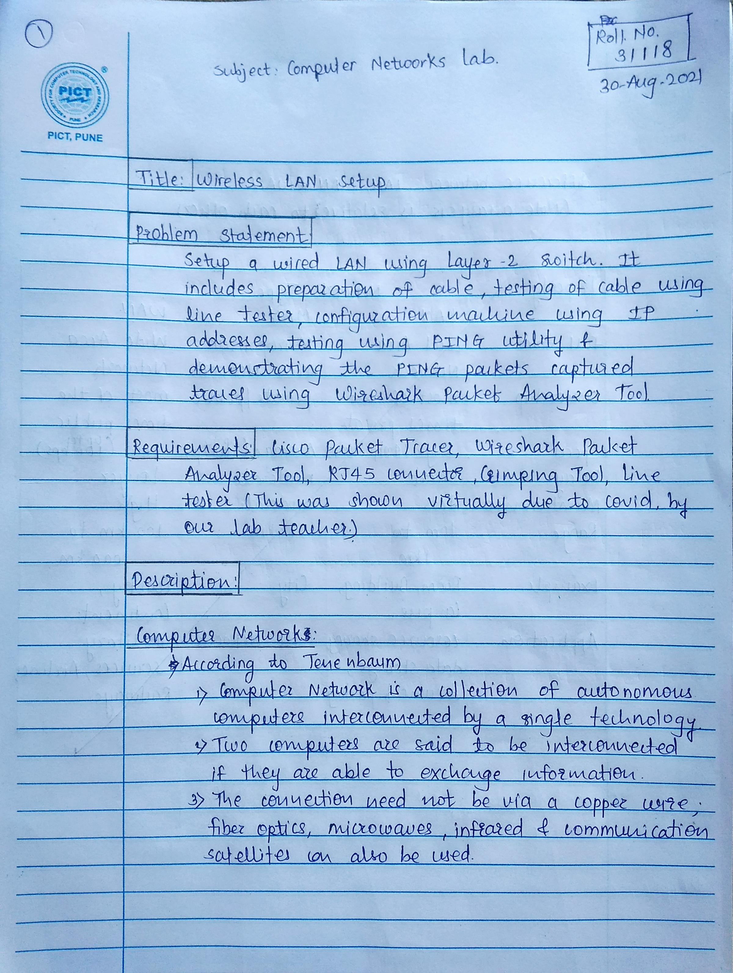

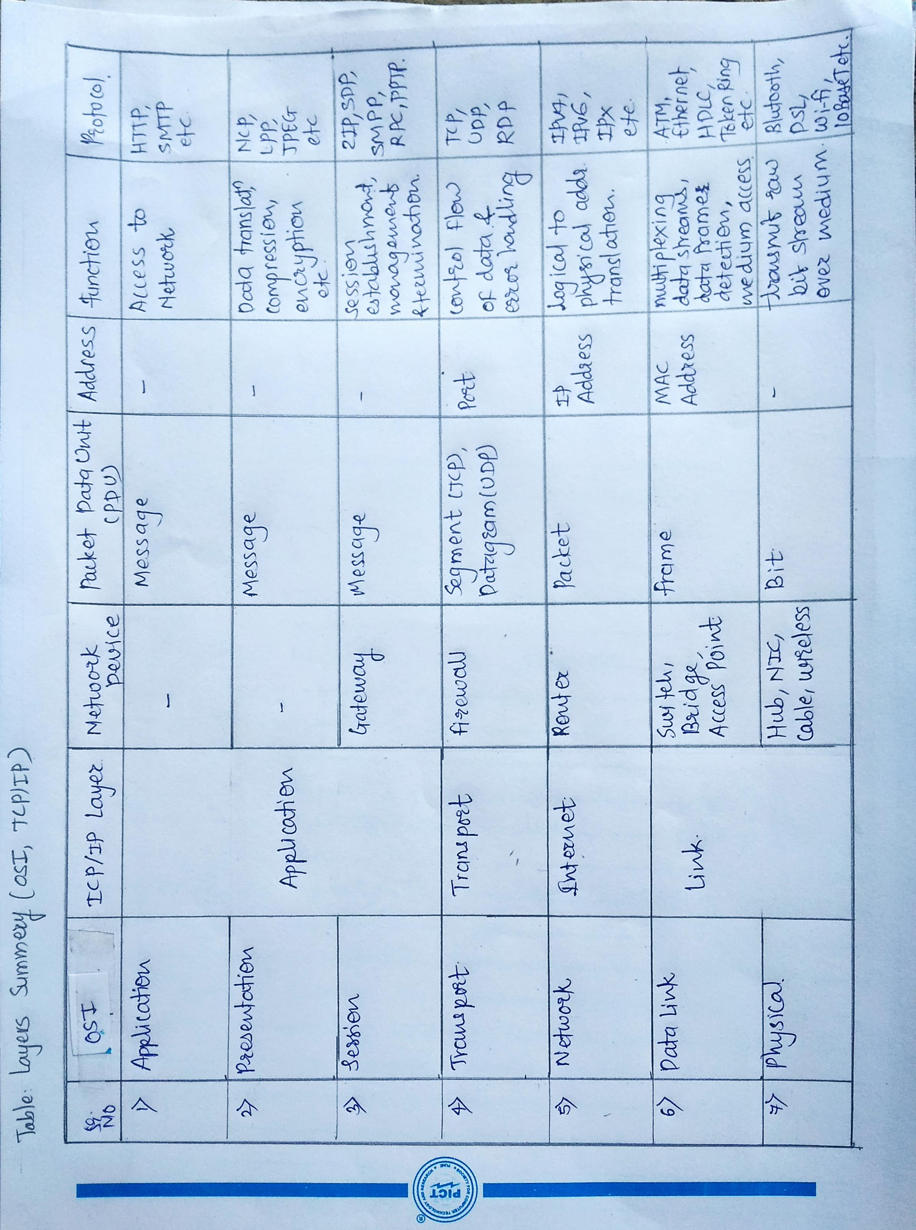

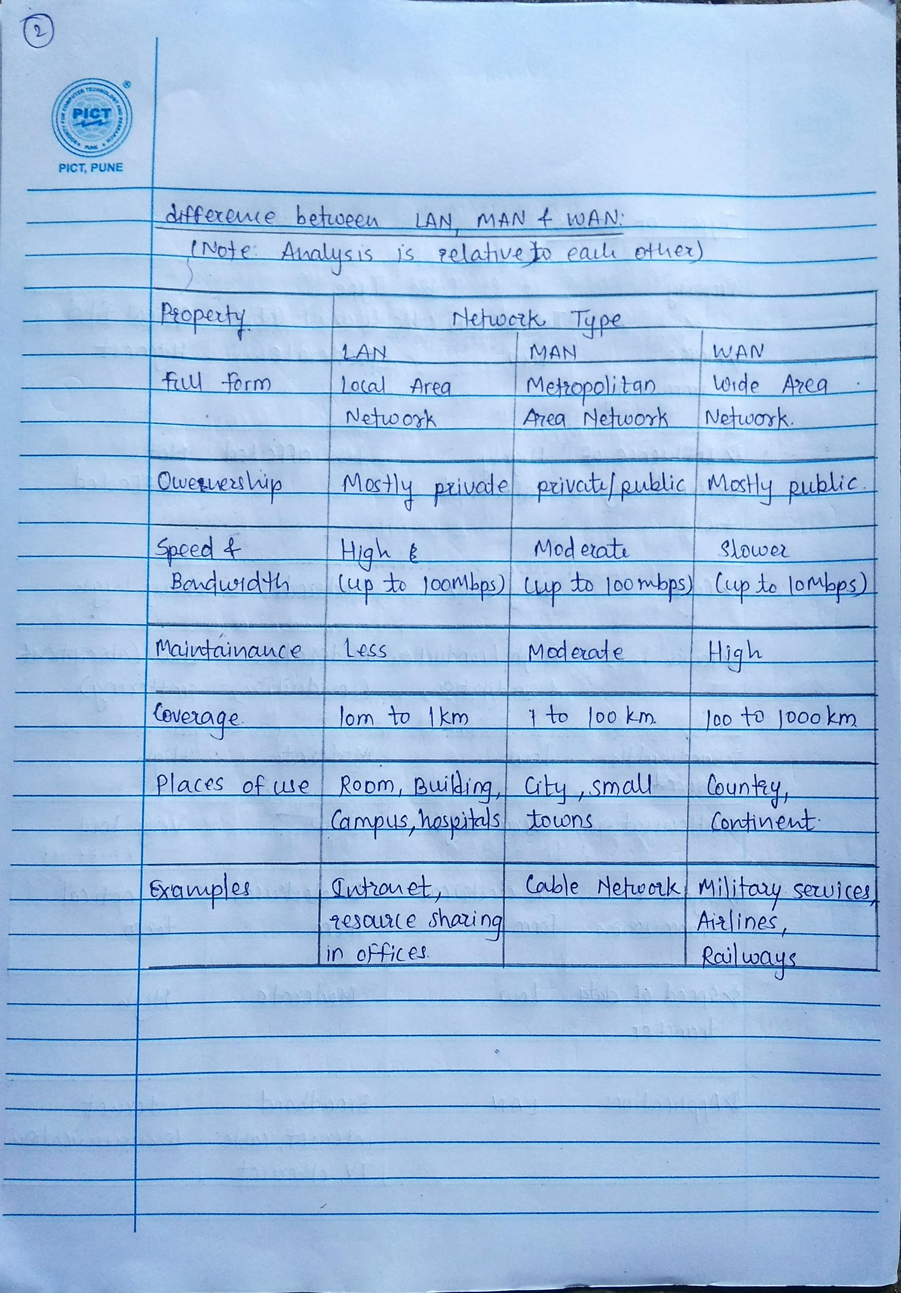

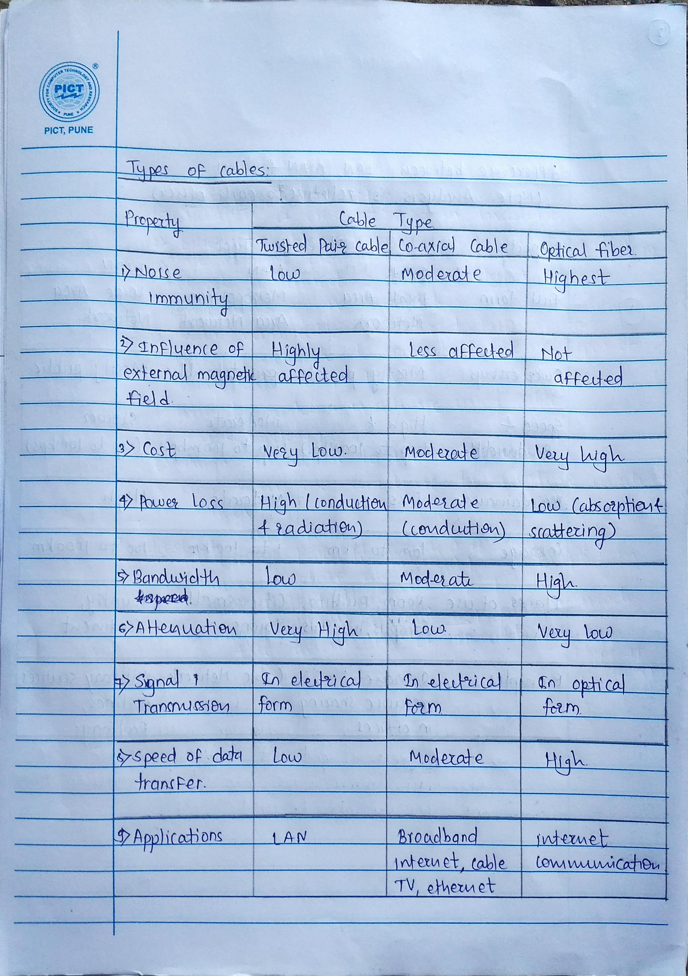

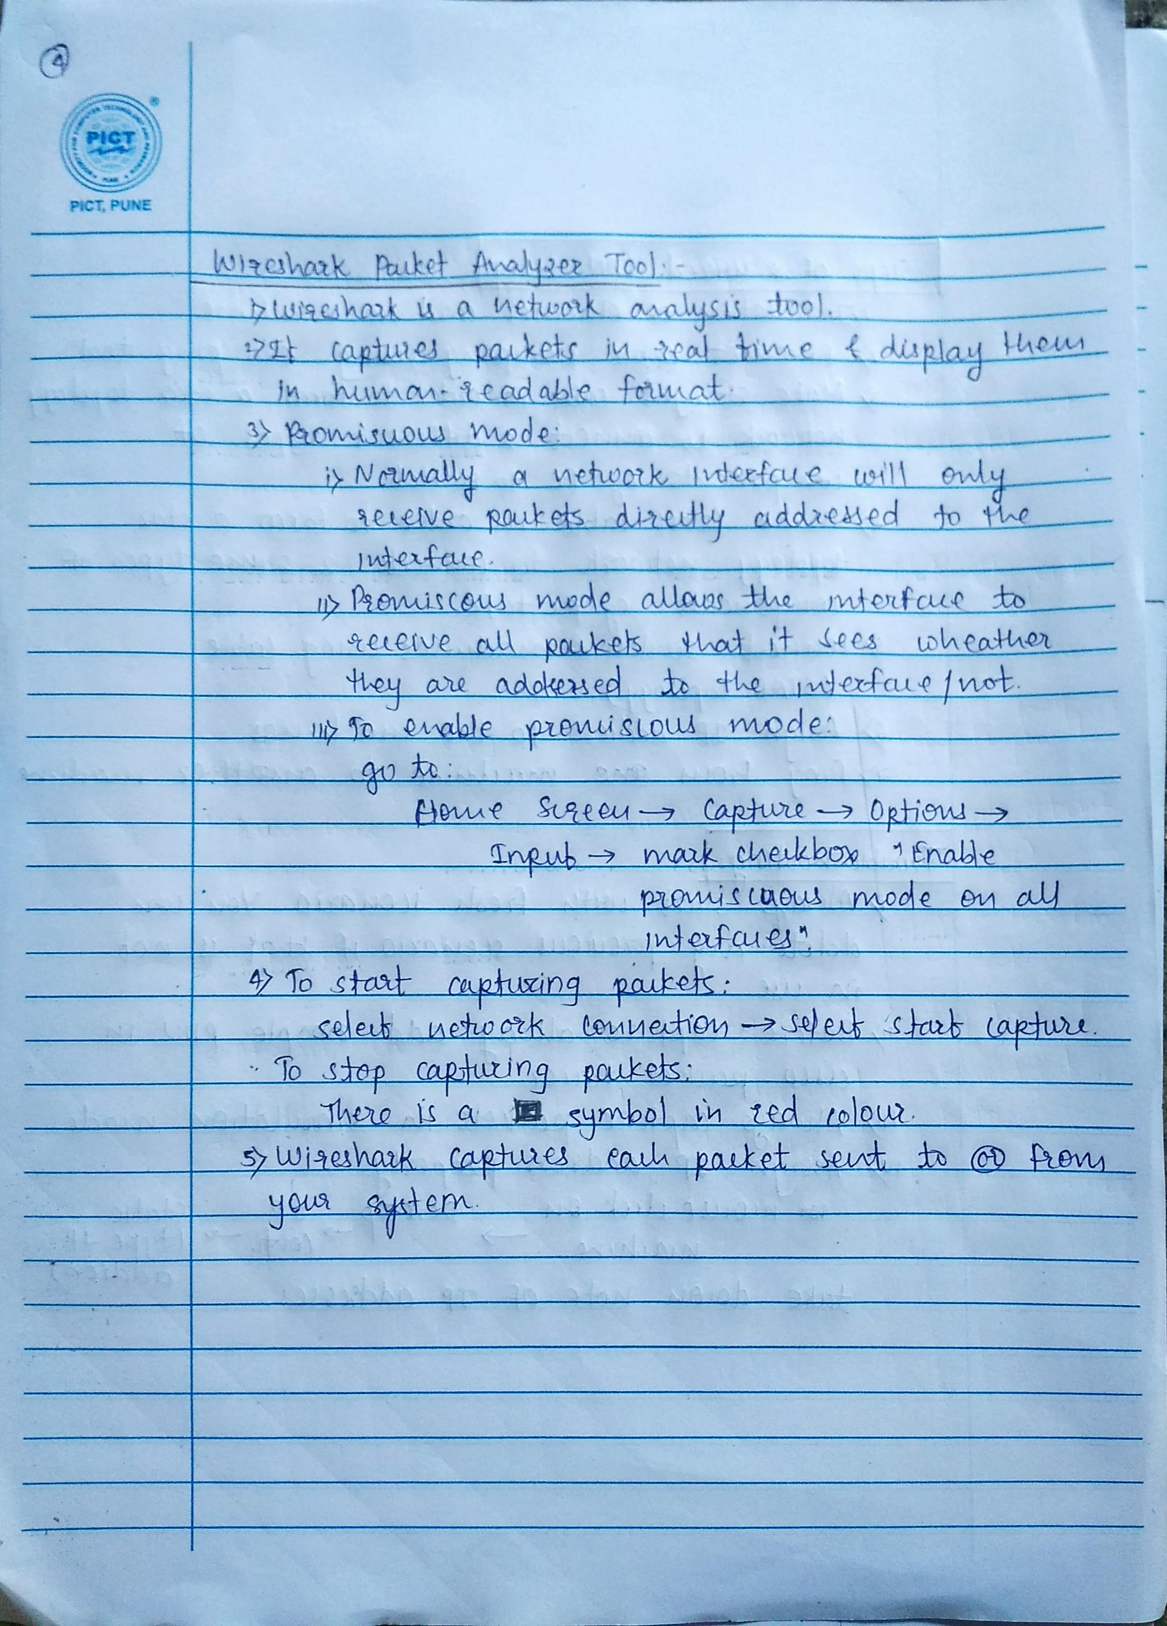

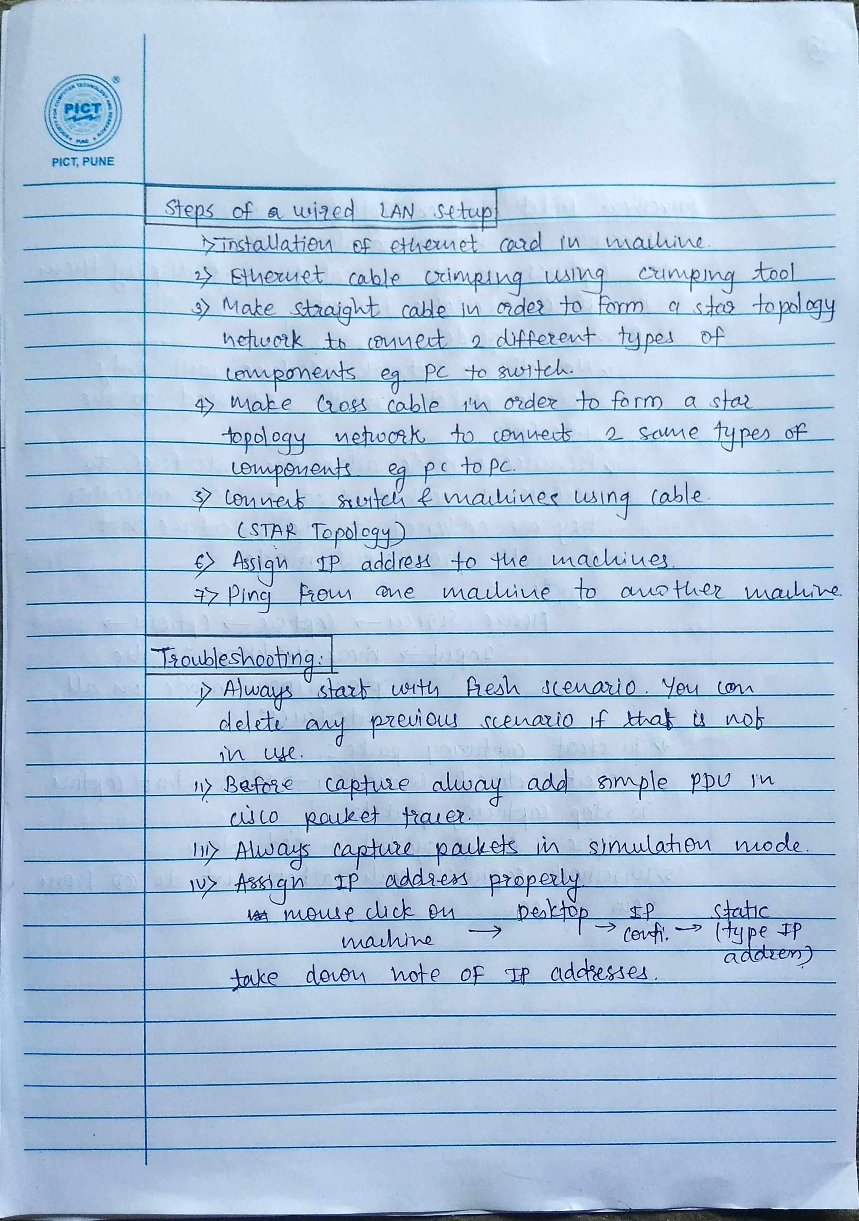

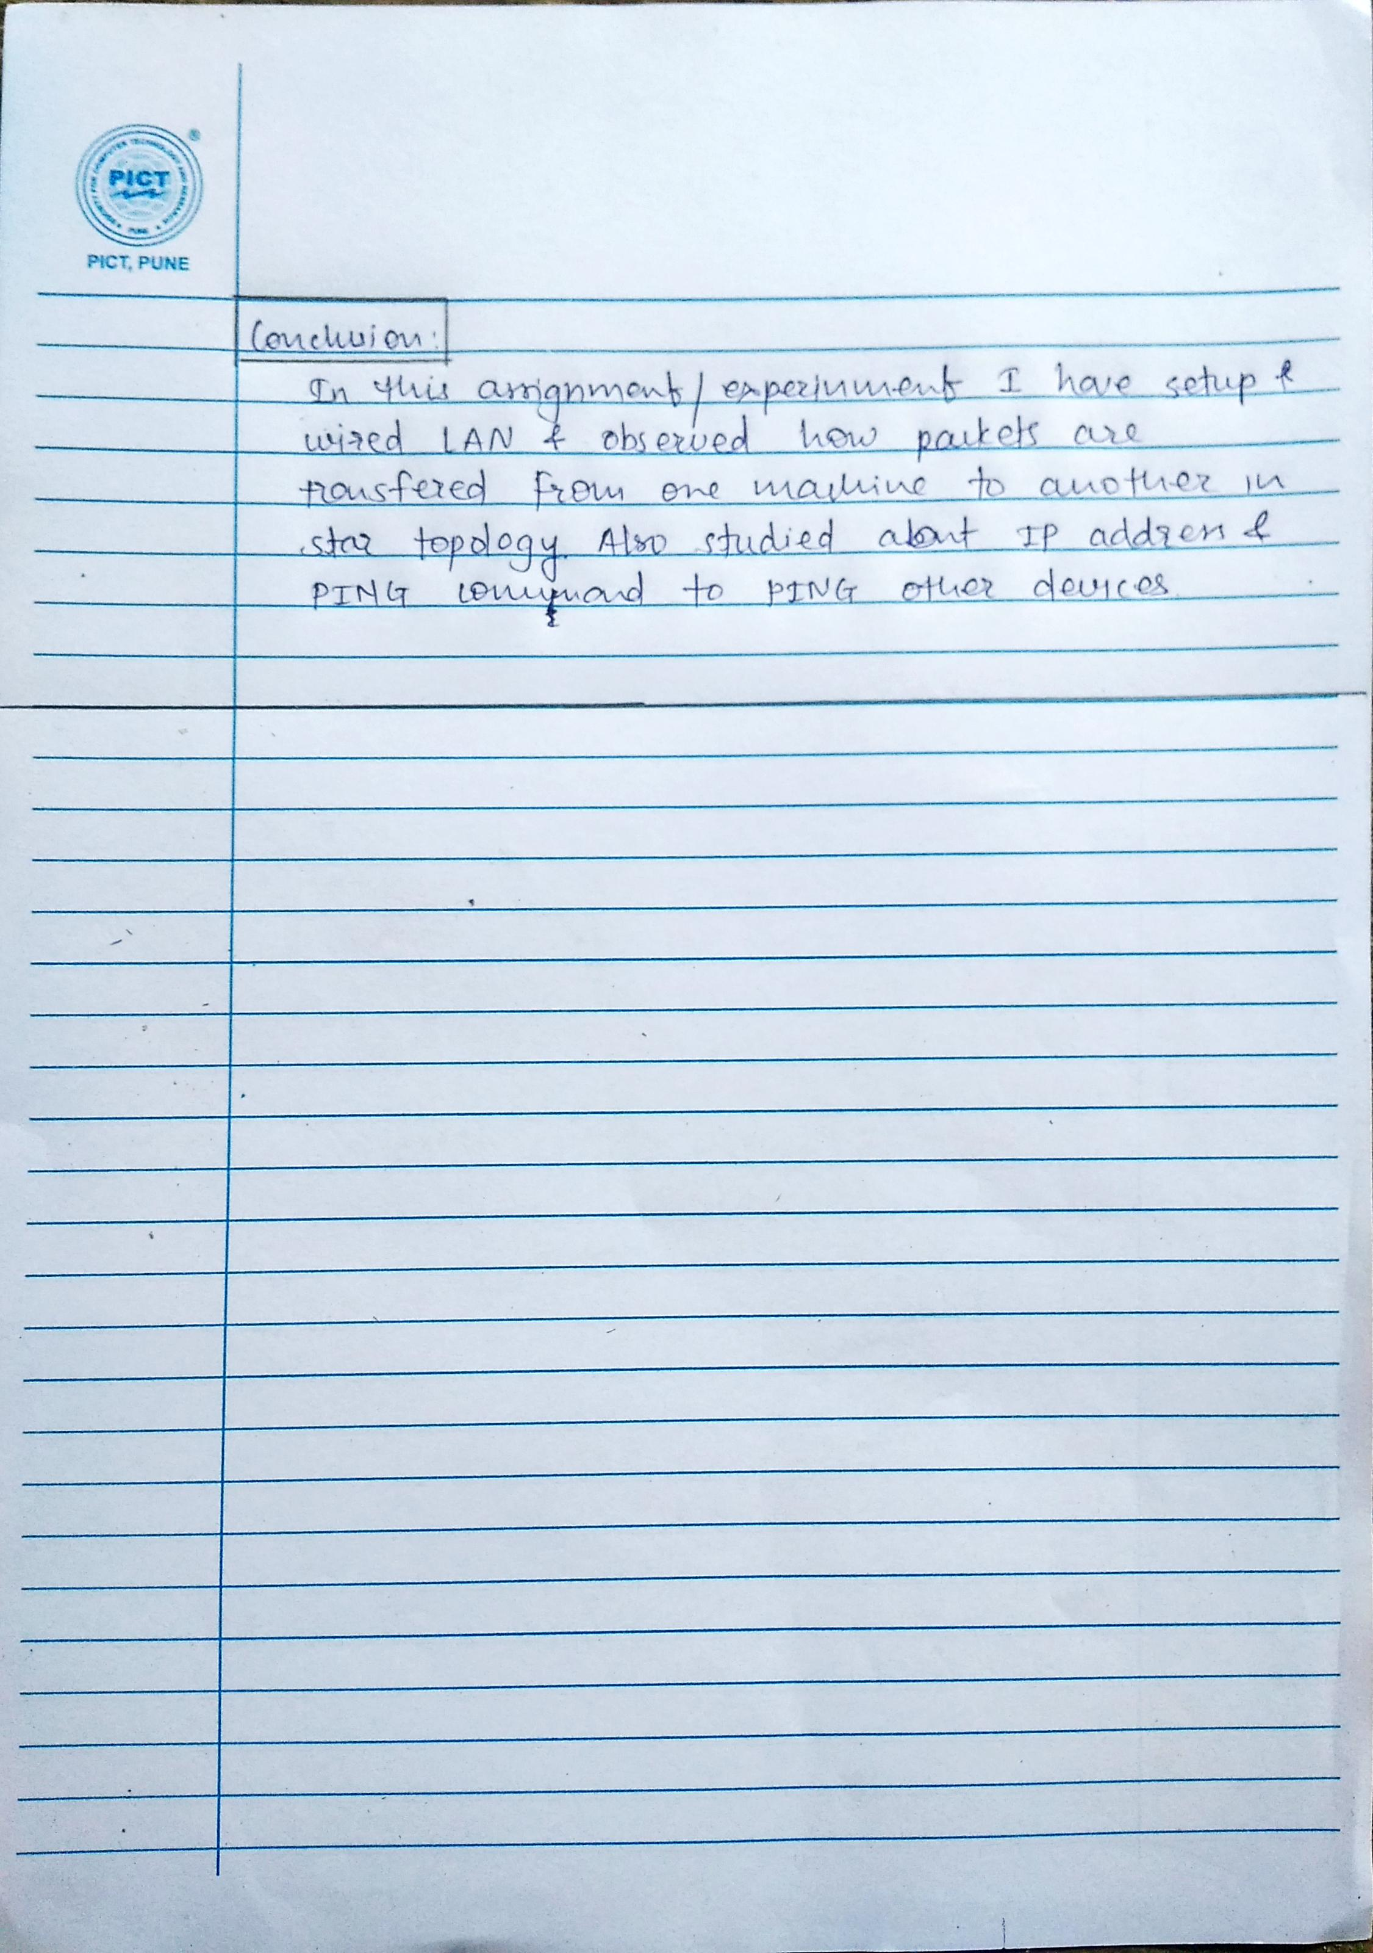

Screenshots of performance:

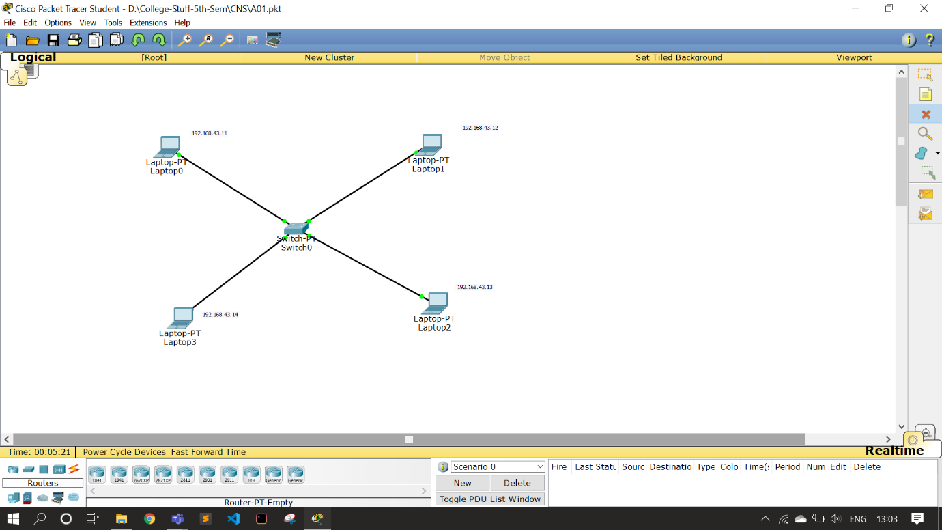

Screenshot-1: figure show wired LAN setup using star topology in CPT (Cisco Packet Tracer)

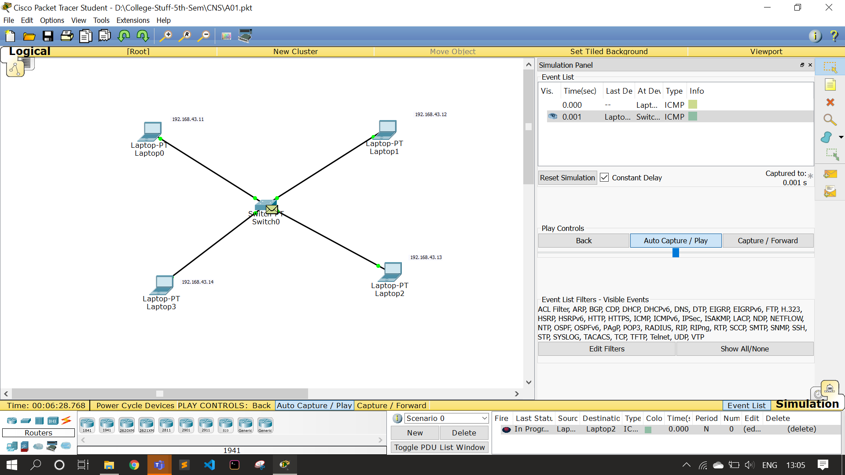

Screenshot-2: figure shows transfer of packet from machine-1 to switch

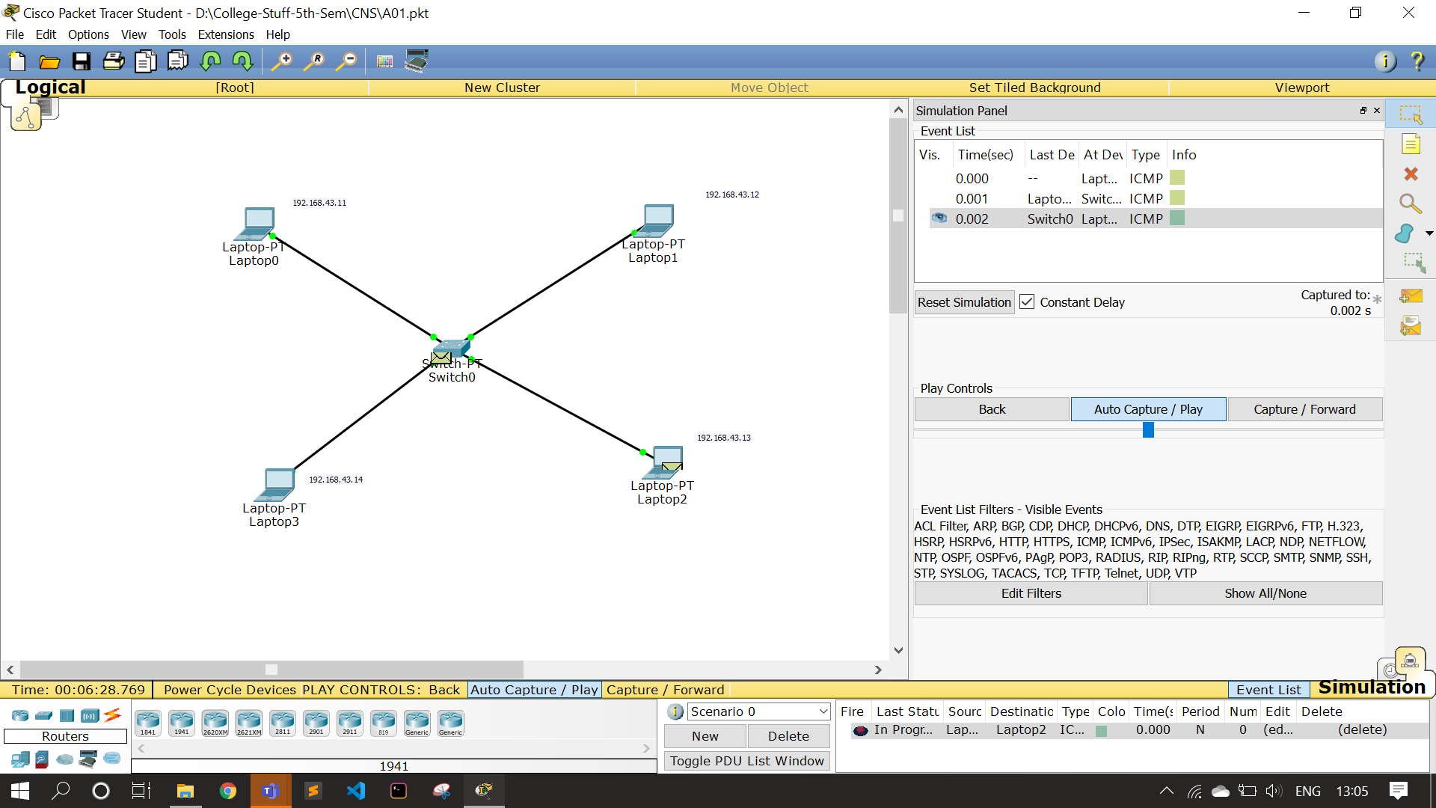

Screenshot-3: figure shows transfer of packet from switch to machine-2

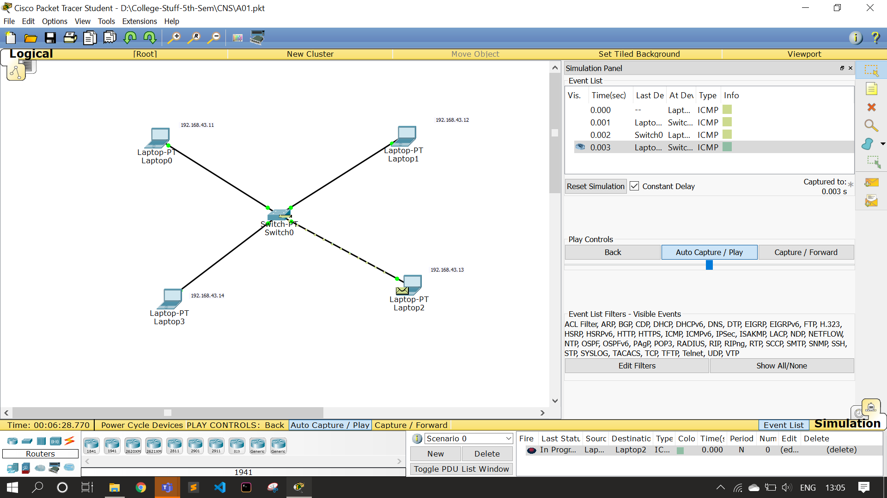

Screenshot-4: figure shows transfer of packet from machine-2 to switch

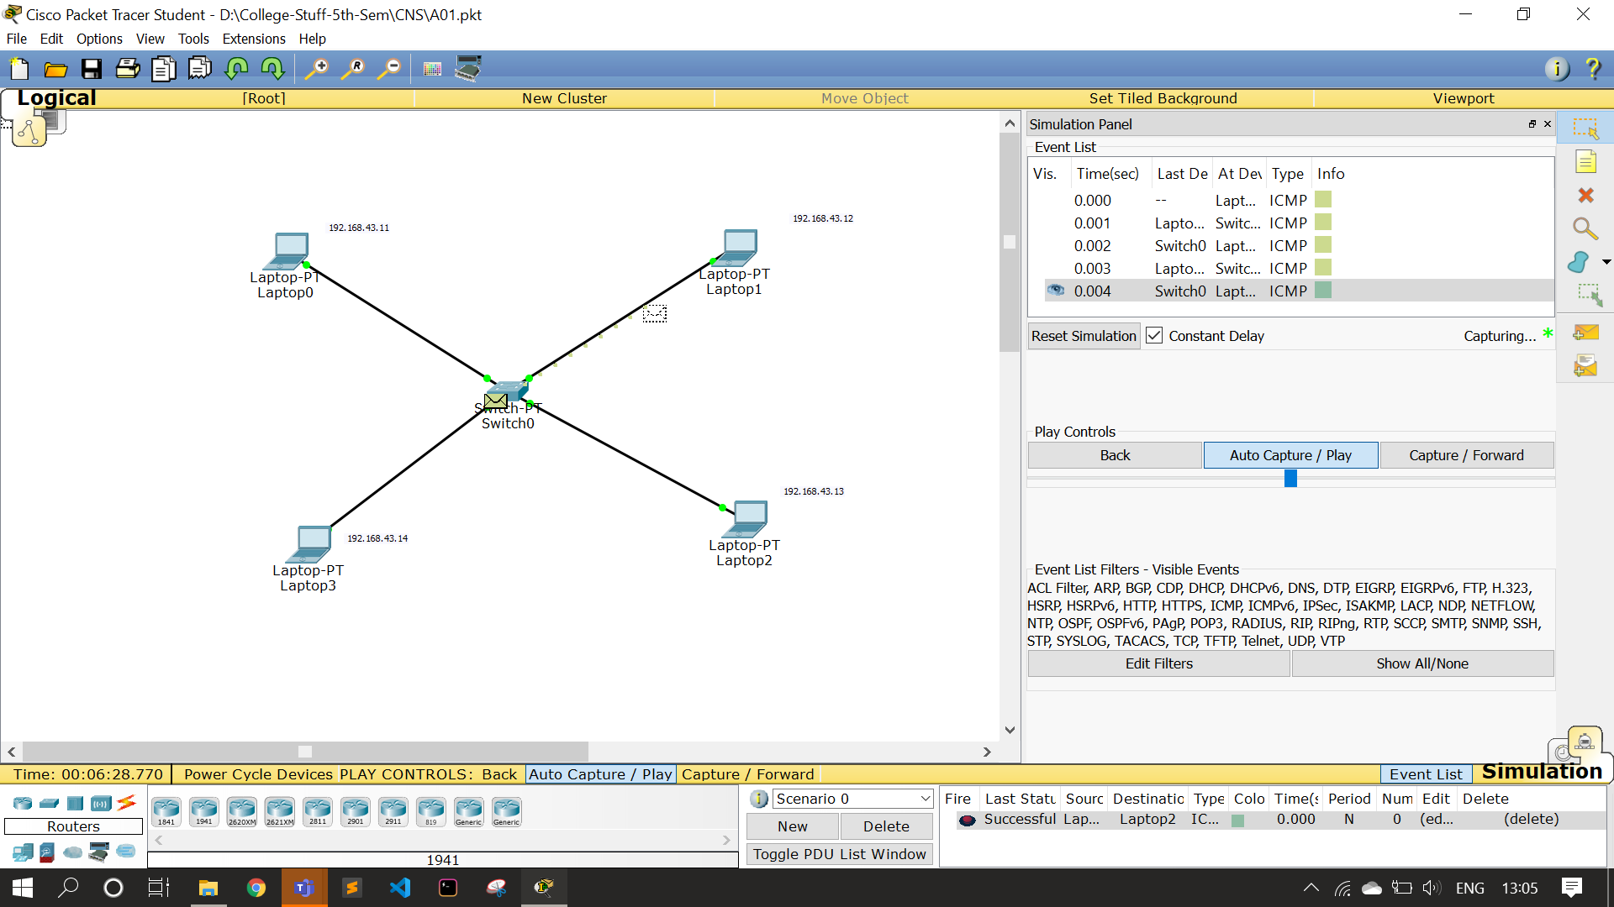

Screenshot-5: figure shows transfer of packet from switch to machine-1

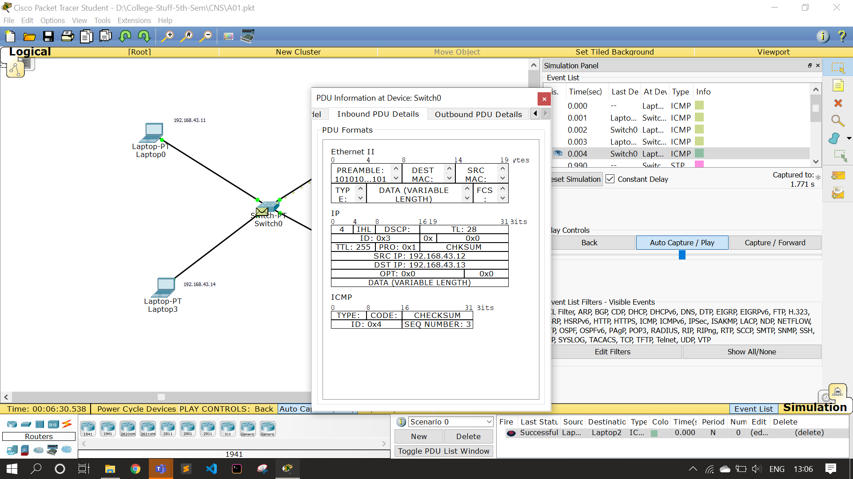

Screenshot-6: figure showing intermediate packet details

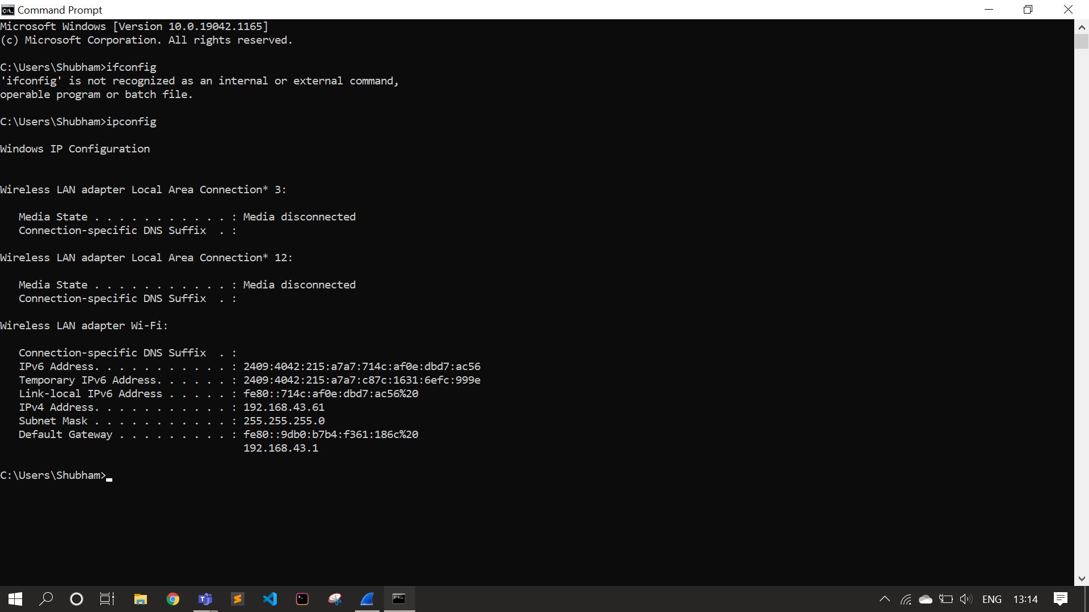

Screenshot-7: IP address of my machine

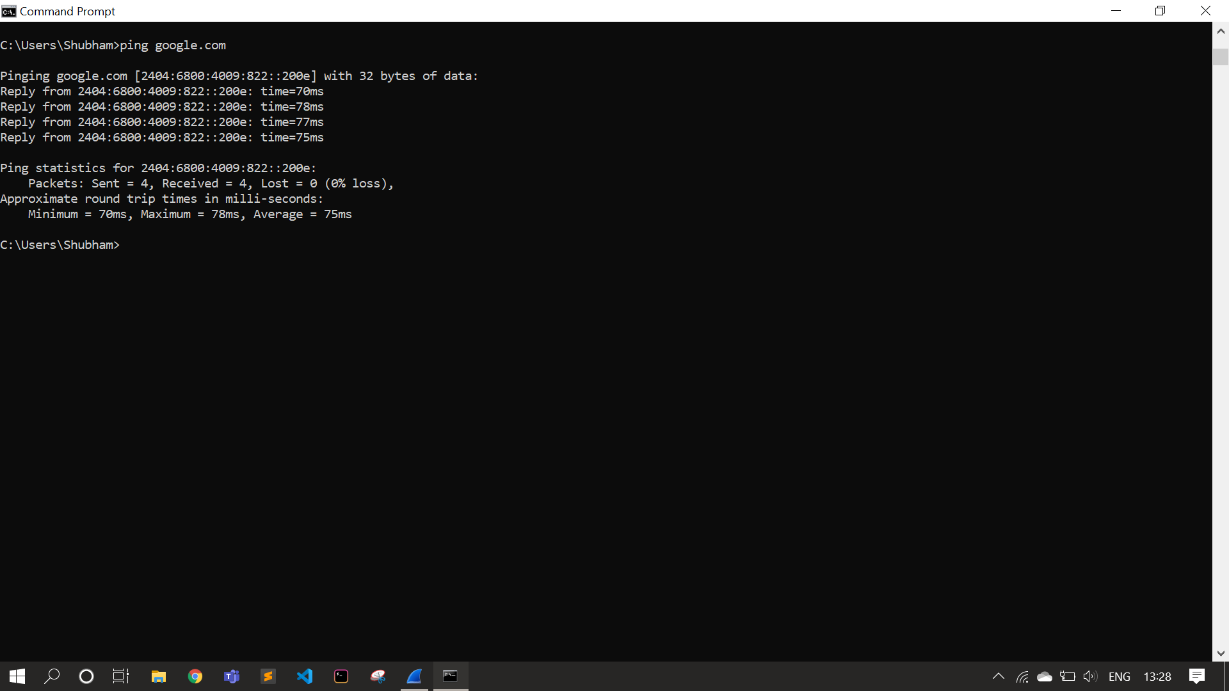

Screenshot-8: Ping command in command prompt

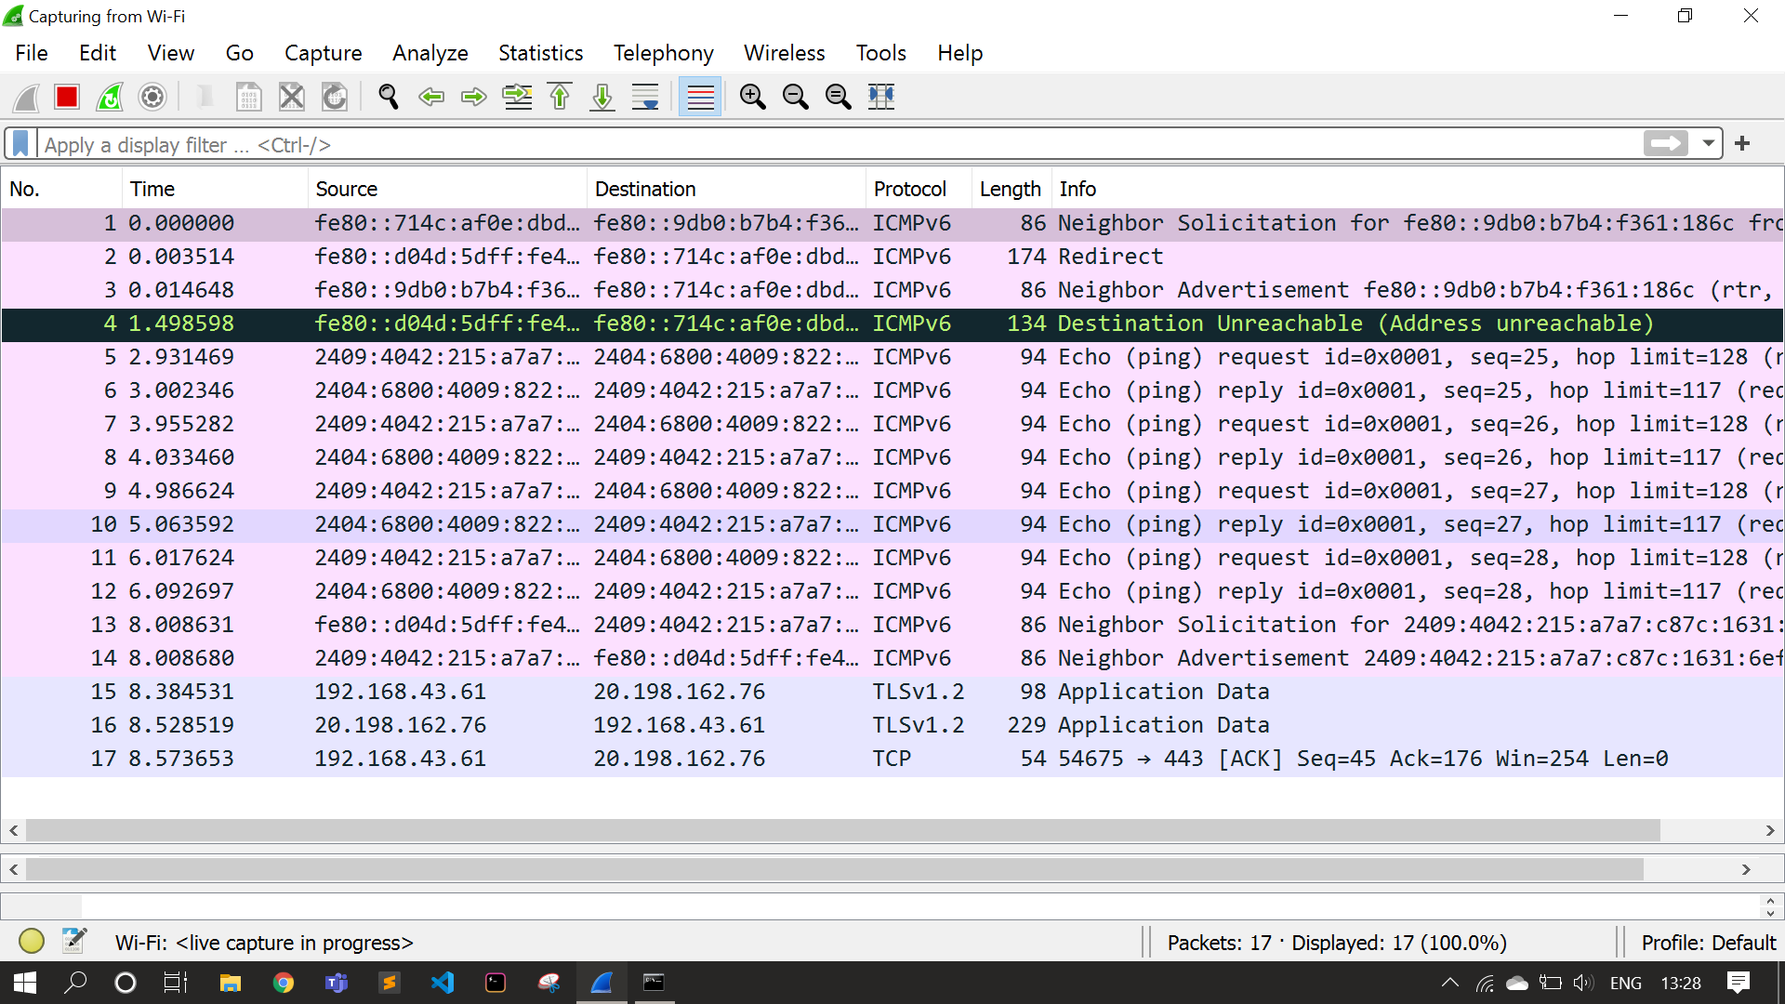

Screenshot-9: Captured packets in Wireshark Packet Analyzer Tool

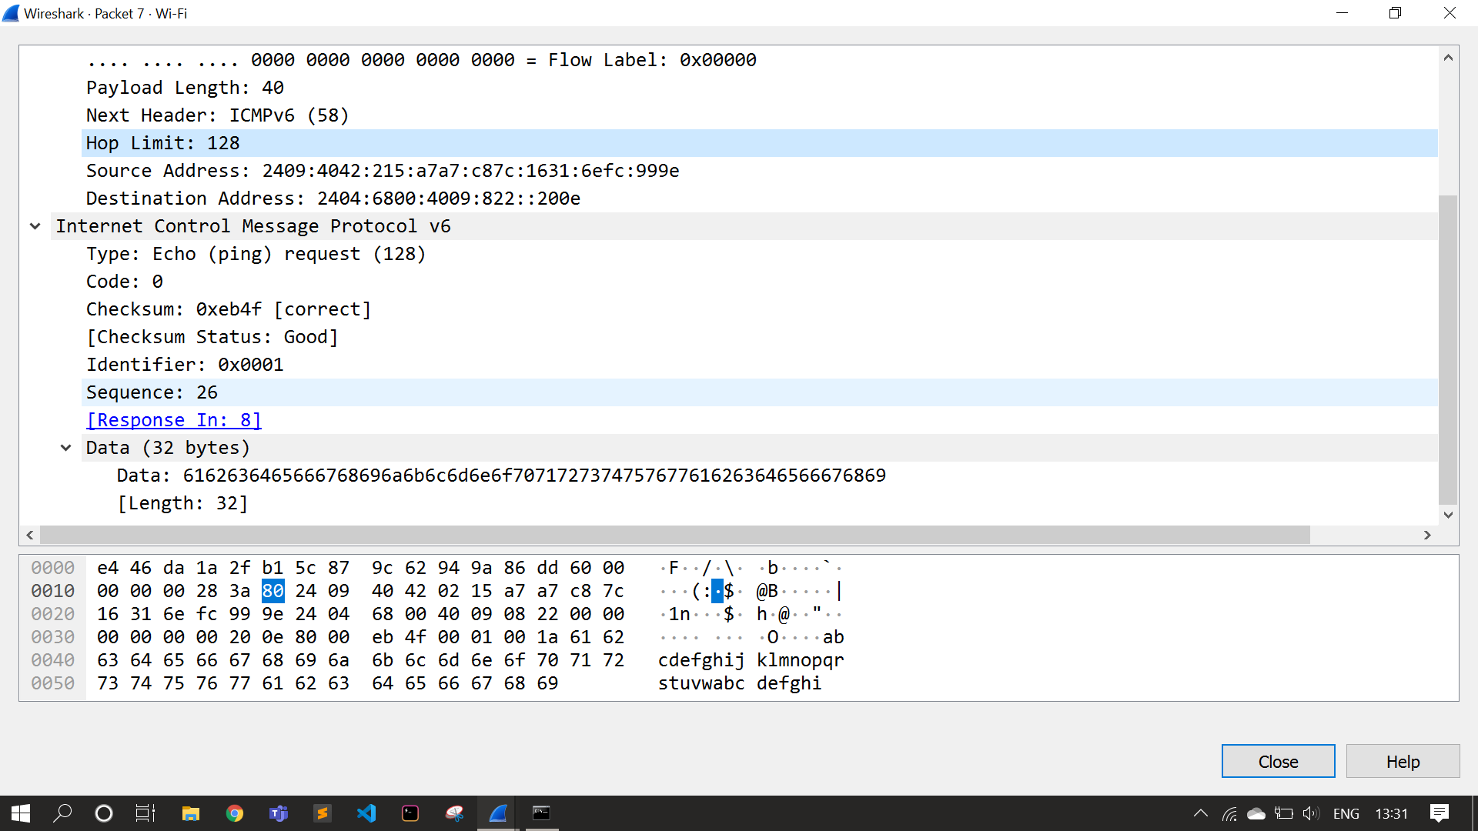

Screenshot-10: IPv6 details

Thank You!